**MECHANICAL LABORATORIES**

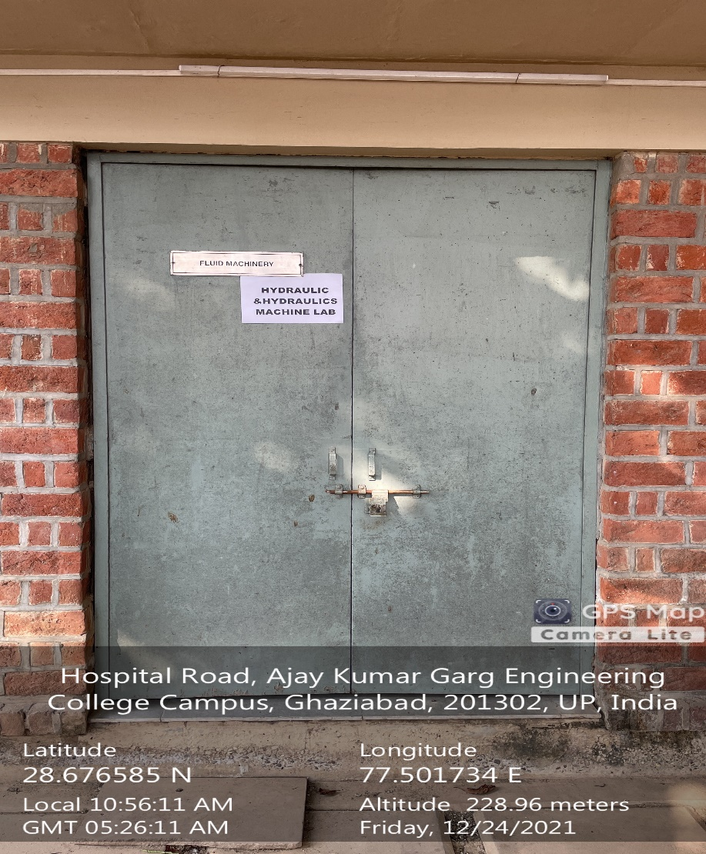

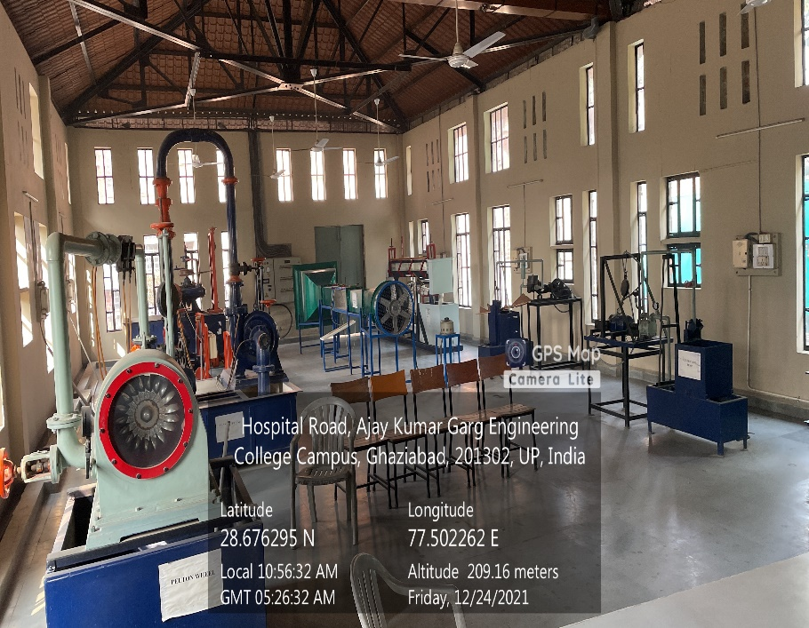

**MECHANICAL BLOCK, GROUND FLOOR, FLUID MACHINERY LAB**

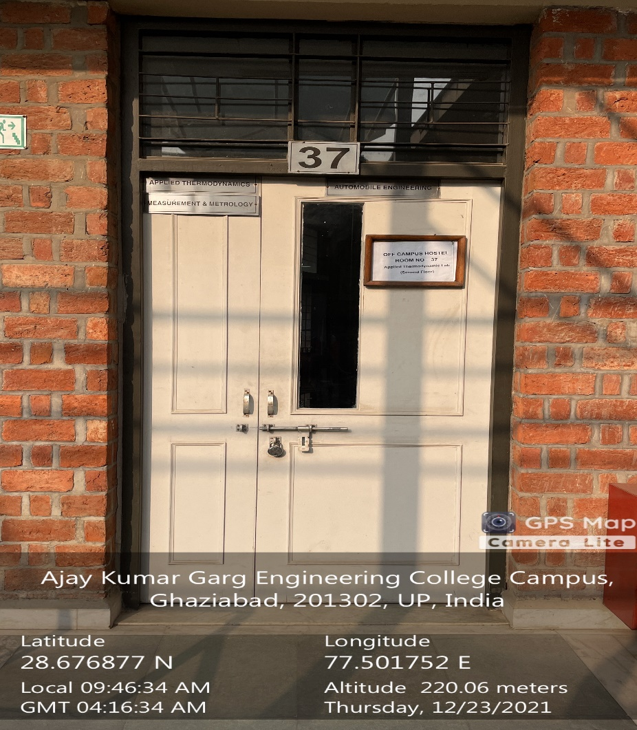

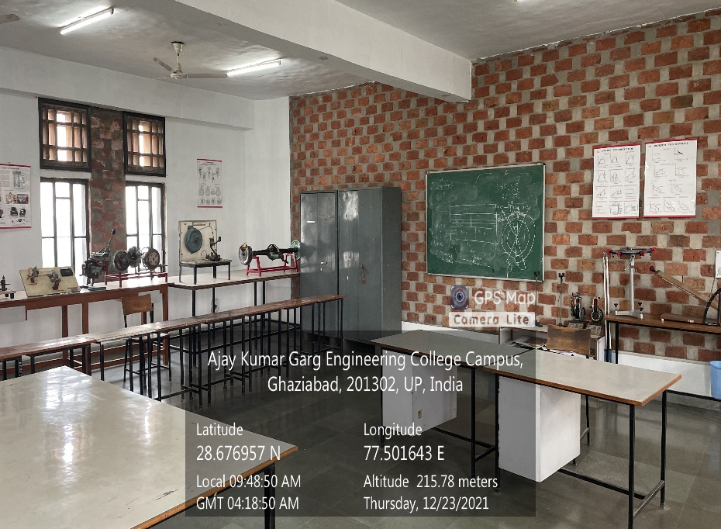

**MECHANICAL BLOCK, SECOND FLOOR, AUTOMOBILE LAB**

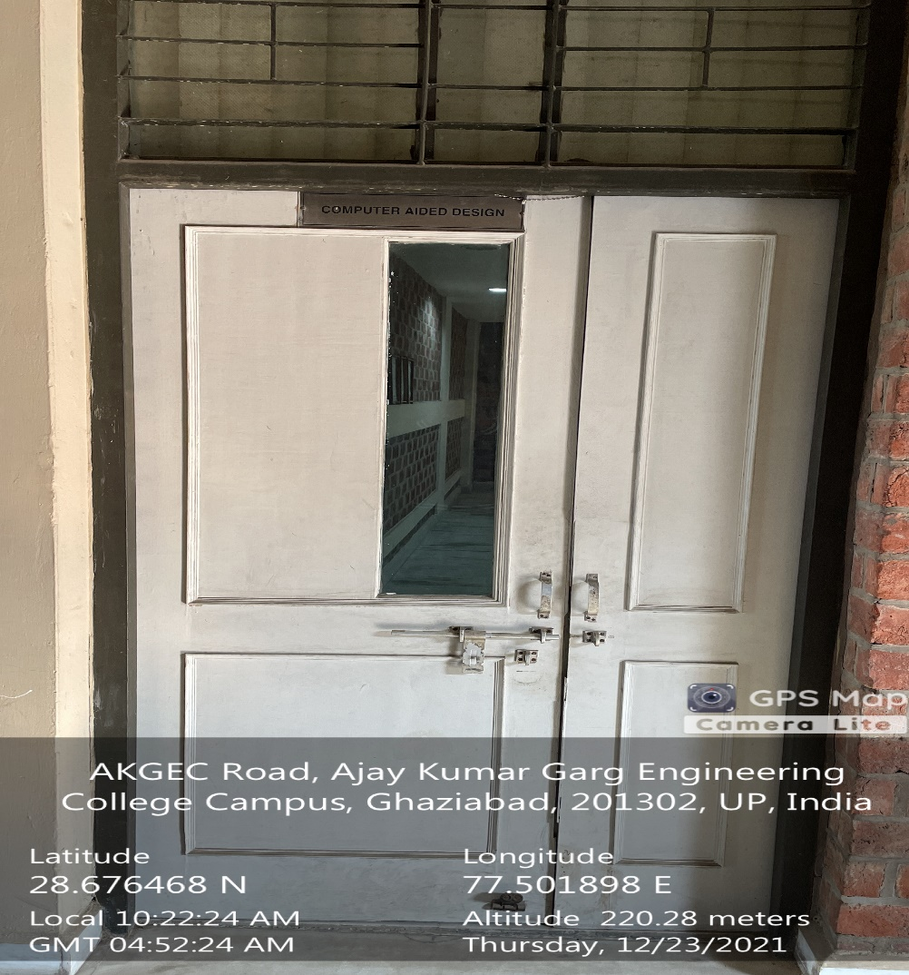

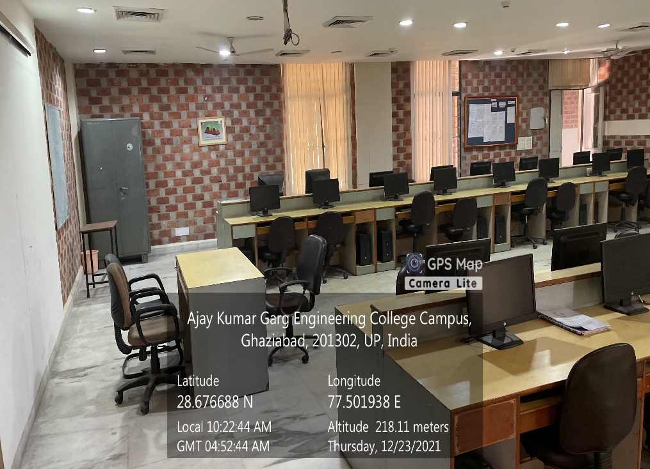

**MECHANICAL BLOCK, SECOND FLOOR, CAD LAB**

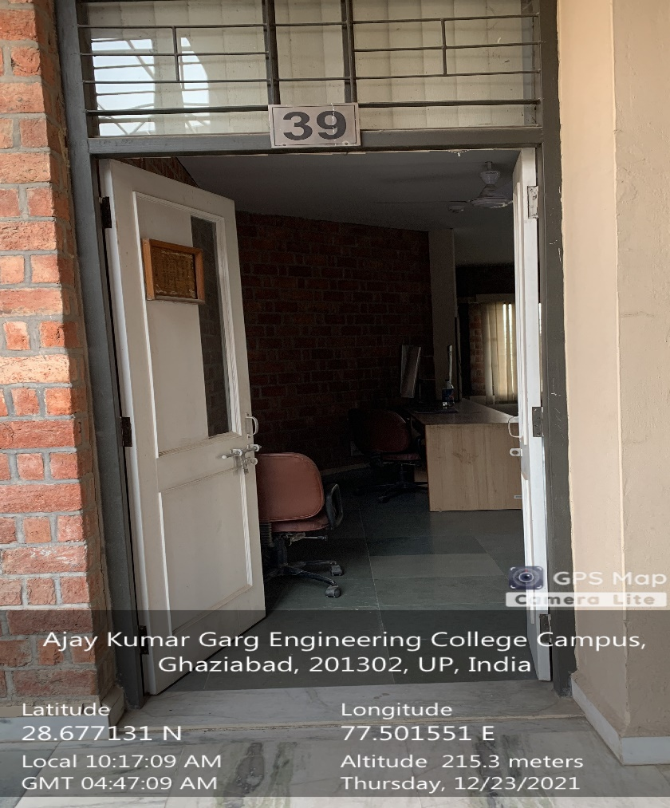

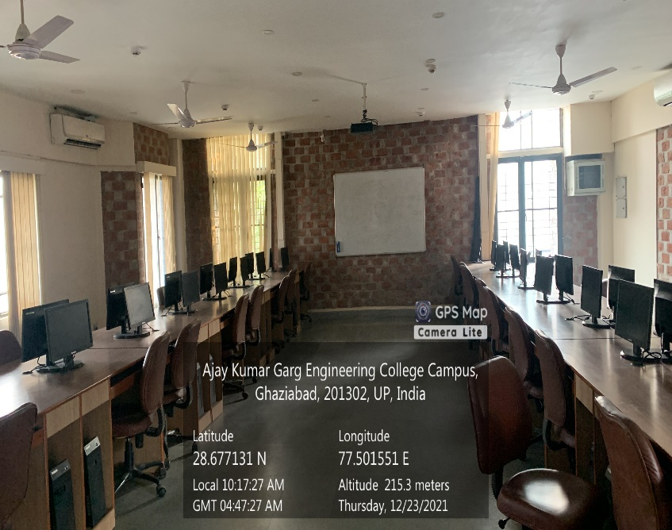

**MECHANICAL BLOCK, SECOND FLOOR, CAM LAB**

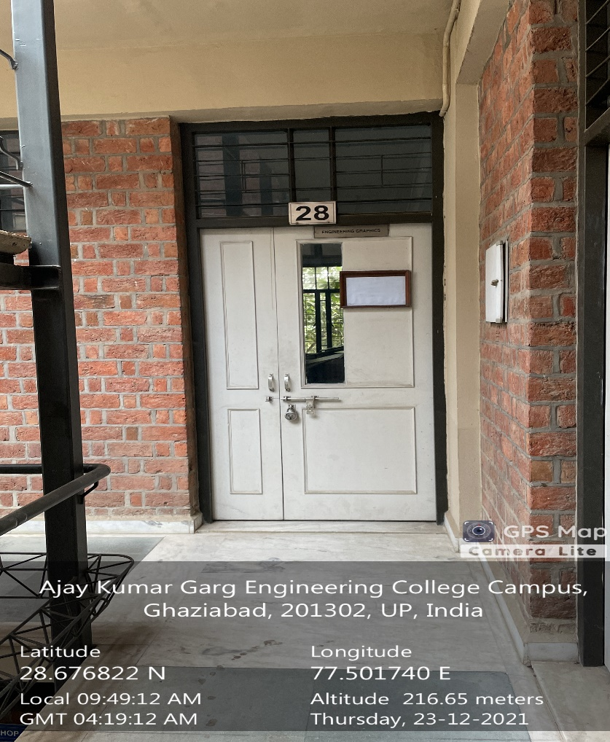

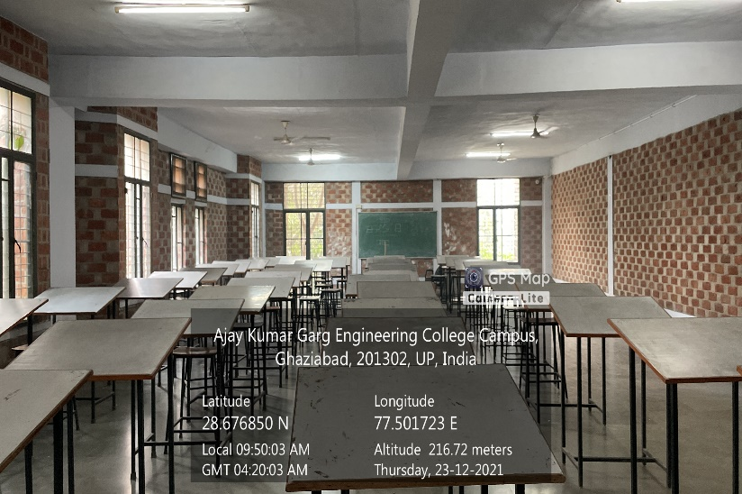

**MECHANICAL BLOCK, SECOND FLOOR, ENGINEERING GRAPHICS LAB**

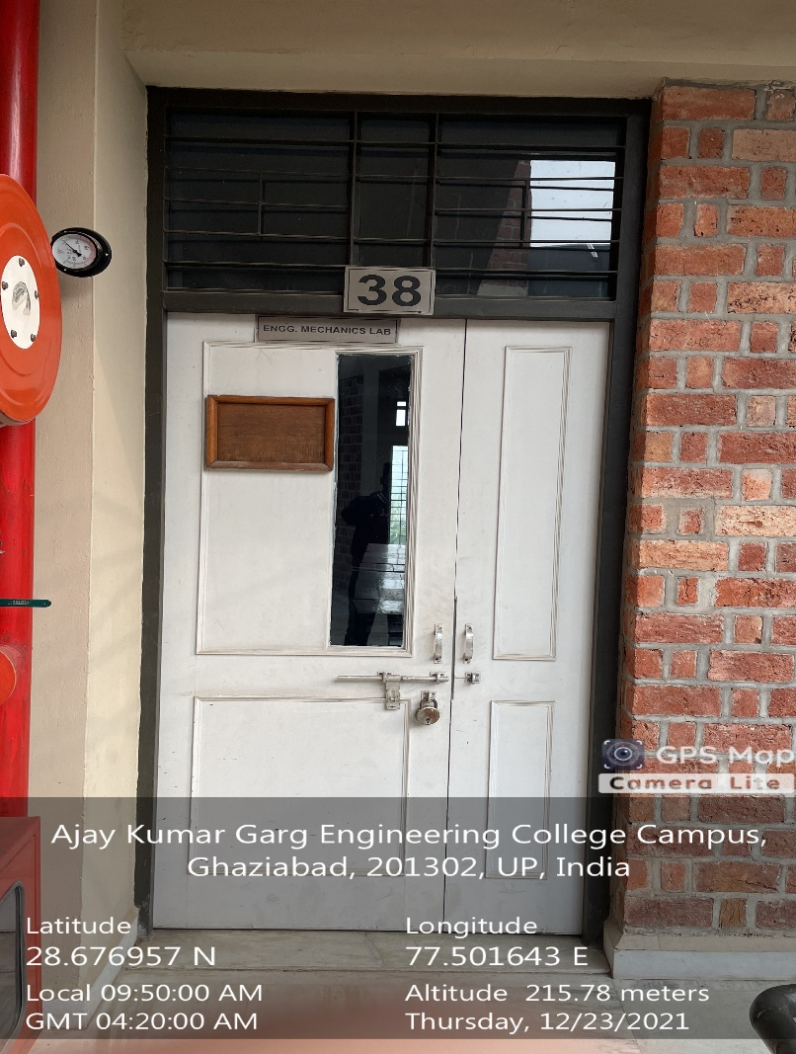

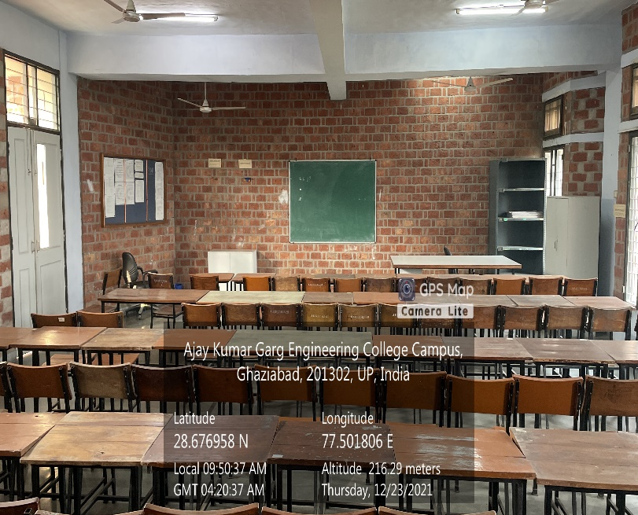

**MECHANICAL BLOCK, SECOND FLOOR, ENGINEERING MECHANICS LAB**

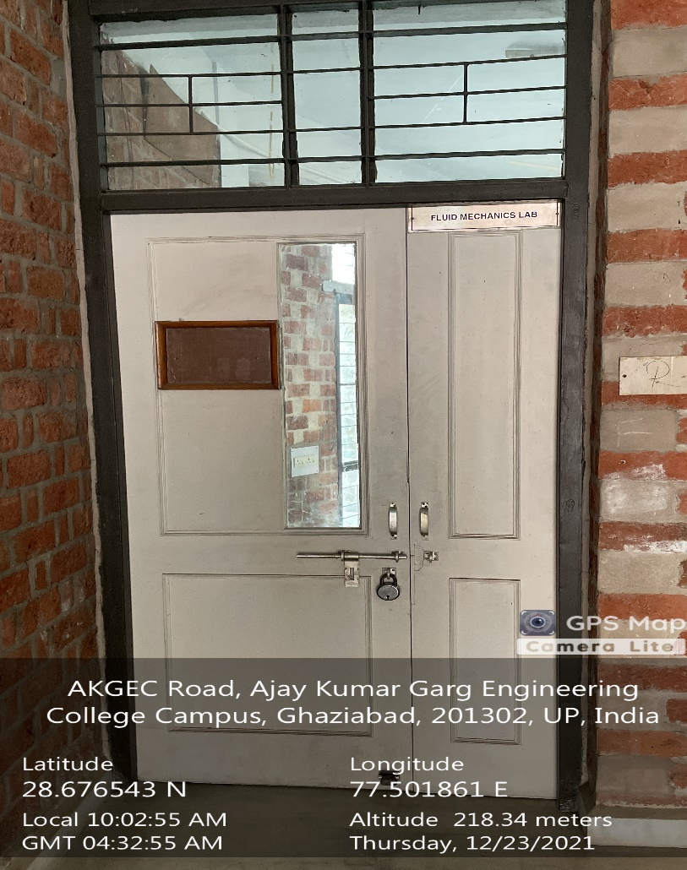

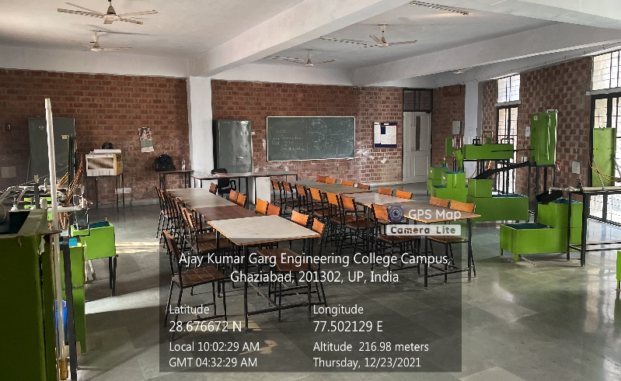

**MECHANICAL BLOCK, SECOND FLOOR, FLUID MECHANICS LAB**

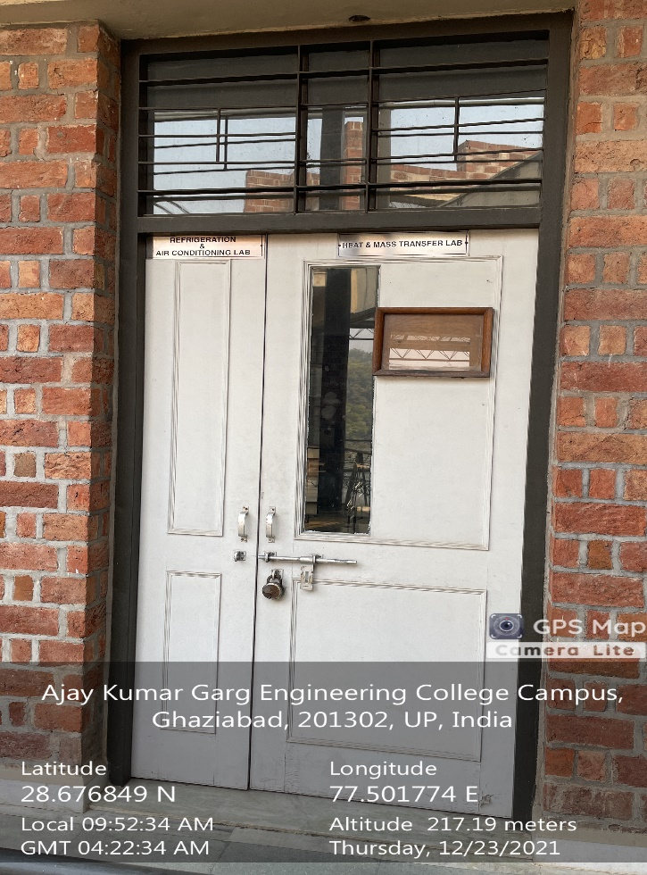

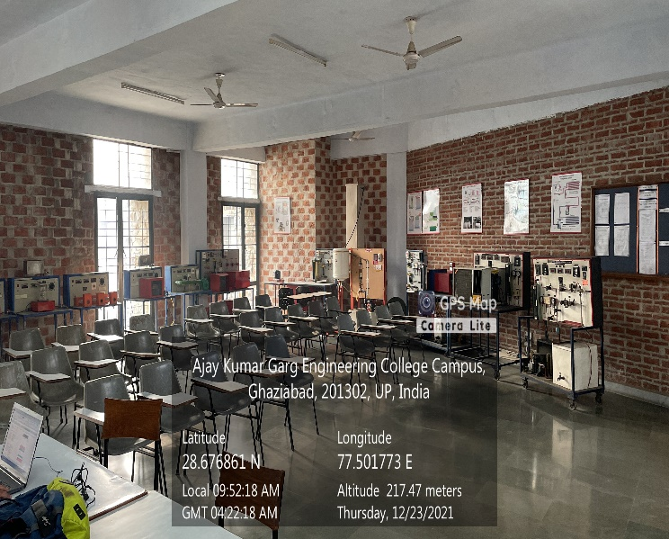

**MECHANICAL BLOCK, SECOND FLOOR, HEAT AND MASS TRANSFER LAB**

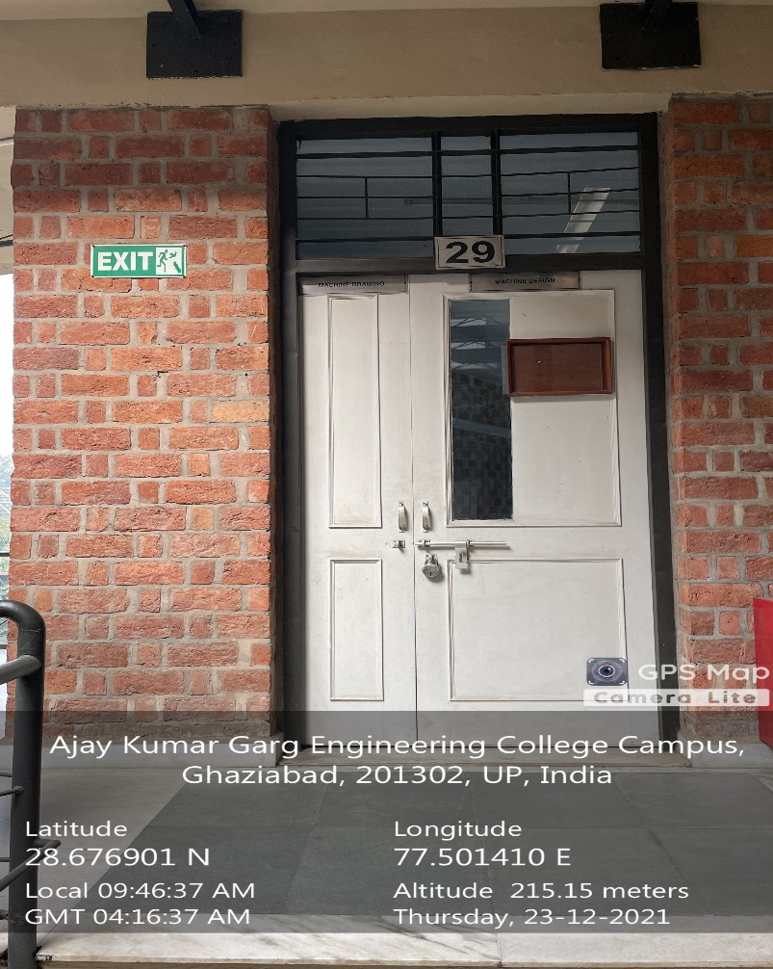

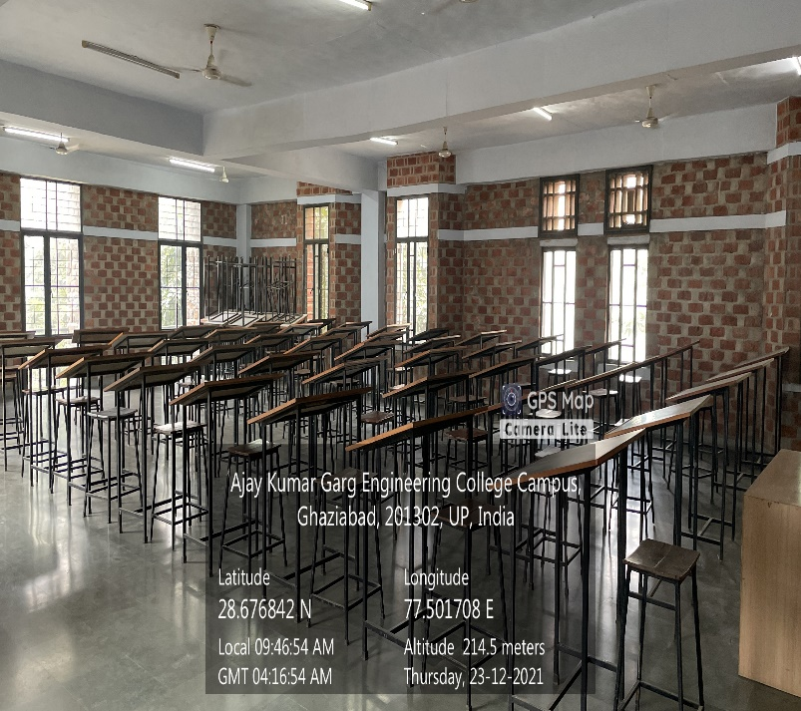

**MECHANICAL BLOCK, GROUND FLOOR, MACHINE DESIGN LAB**

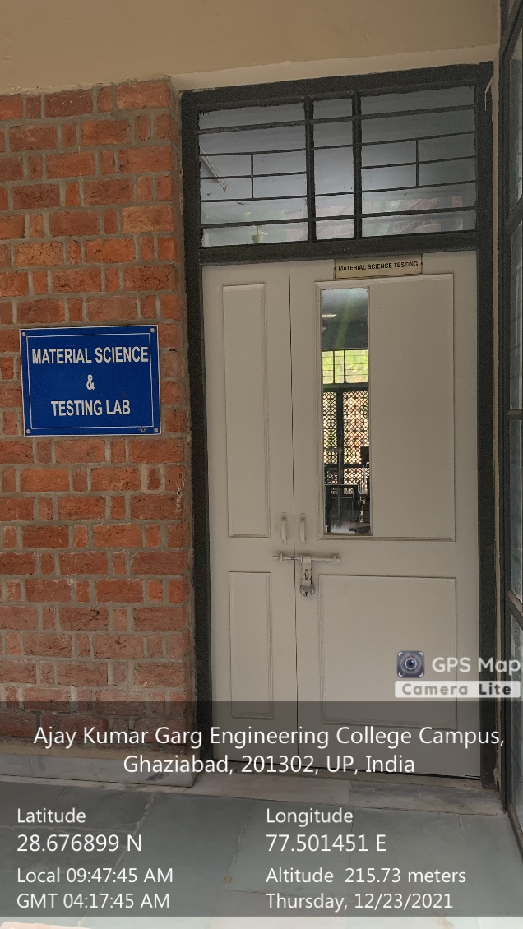

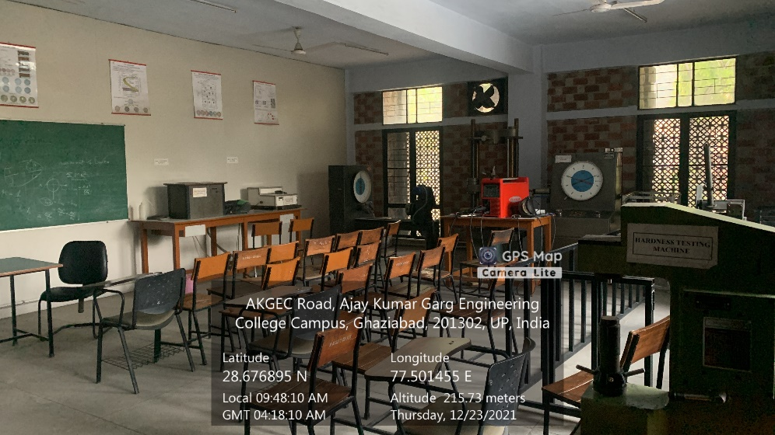

**MECHANICAL BLOCK, GROUND FLOOR, MATERIAL SCIENCE & TESTING LAB**

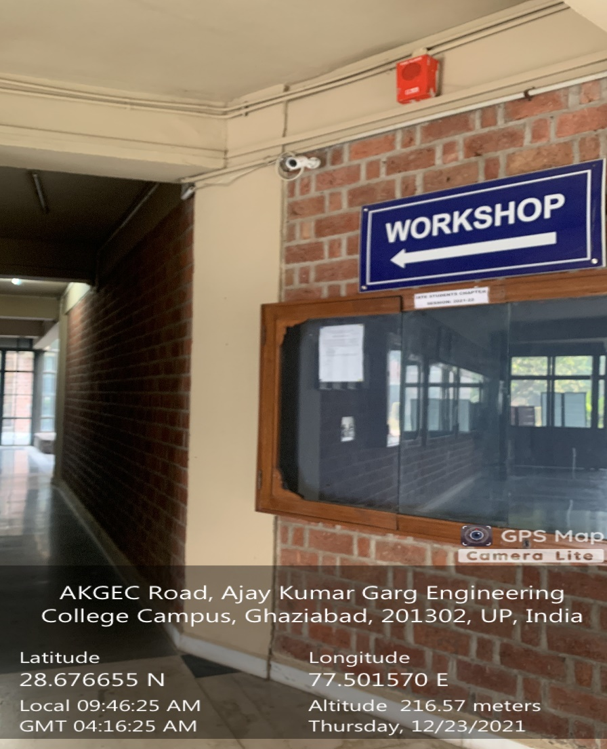

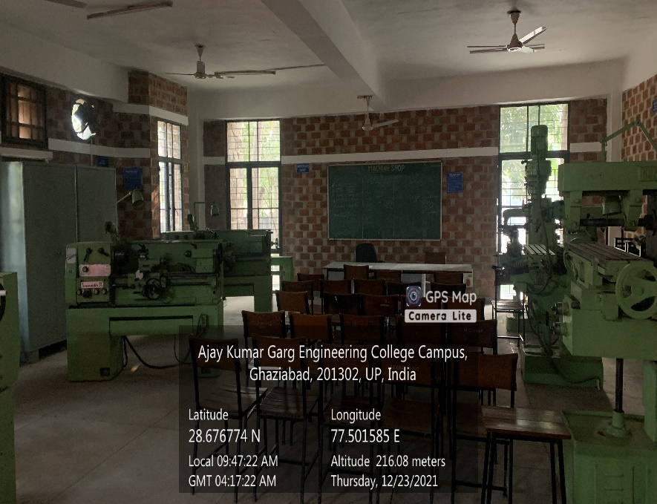

**MECHANICAL BLOCK, GROUND FLOOR, ME ADDITIONAL WORKSHOP 1**





**MECHANICAL BLOCK, GROUND FLOOR, ME ADDITIONAL WORKSHOP 2**

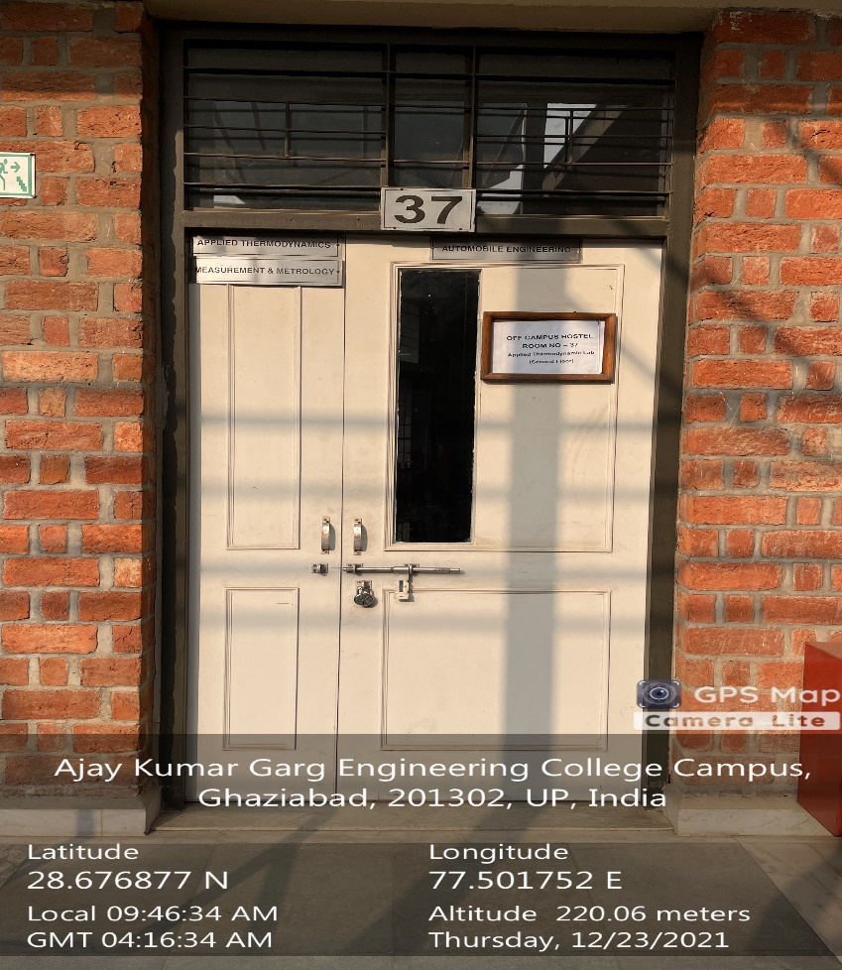

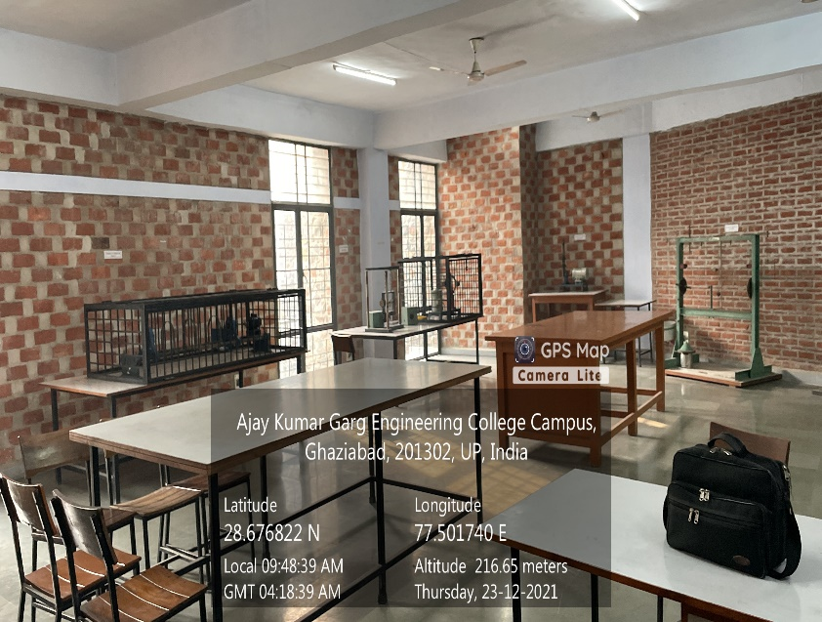

**MECHANICAL BLOCK, SECOND FLOOR, MEASUREMENT AND METROLOGY LAB**





**MECHANICAL BLOCK SECOND FLOOR, REFRIGERATION & AIR CONDITIONING LAB**



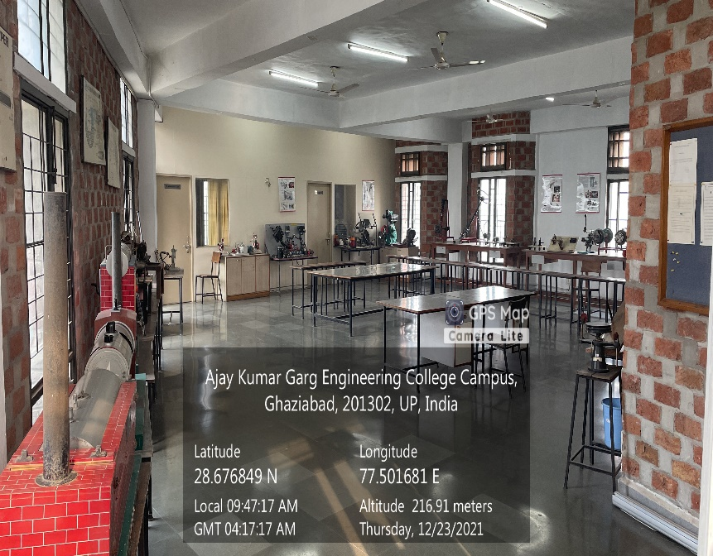

**MECHANICAL BLOCK, SECOND FLOOR, THERMODYNAMICS LAB**

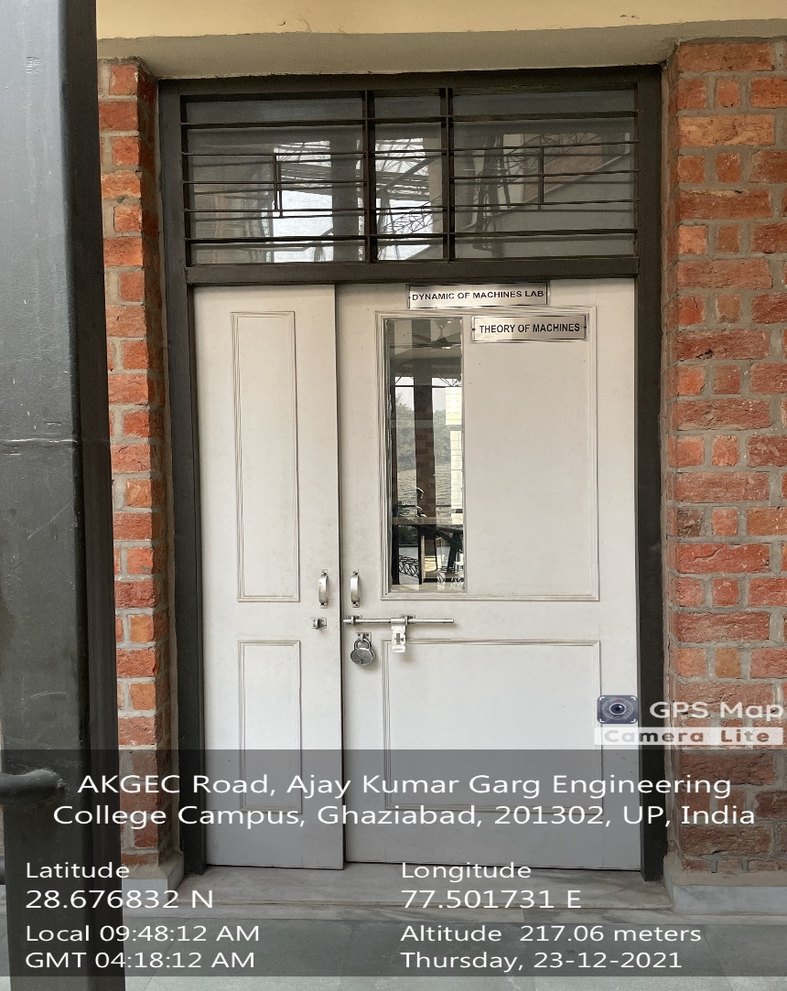

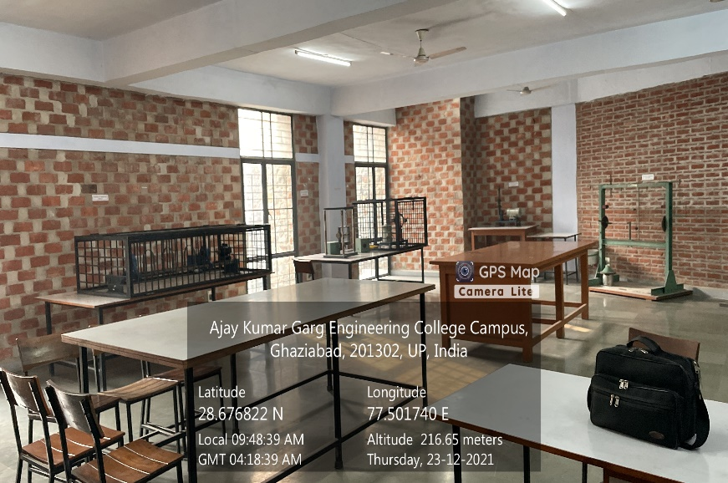

**MECHANICAL BLOCK, FIRST FLOOR, TOM LAB**

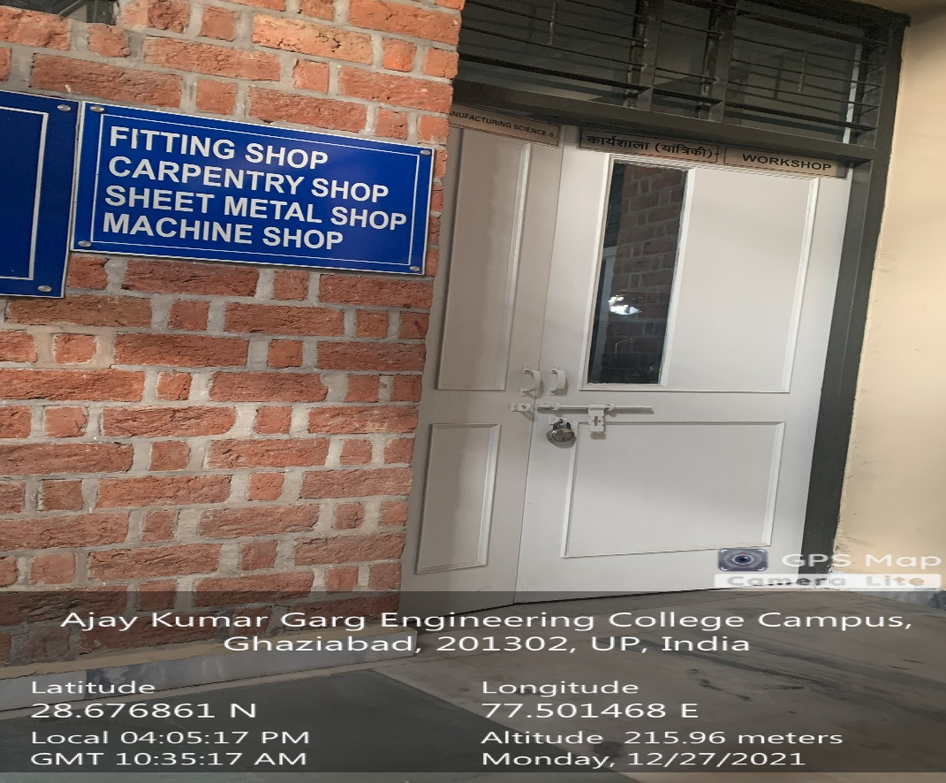

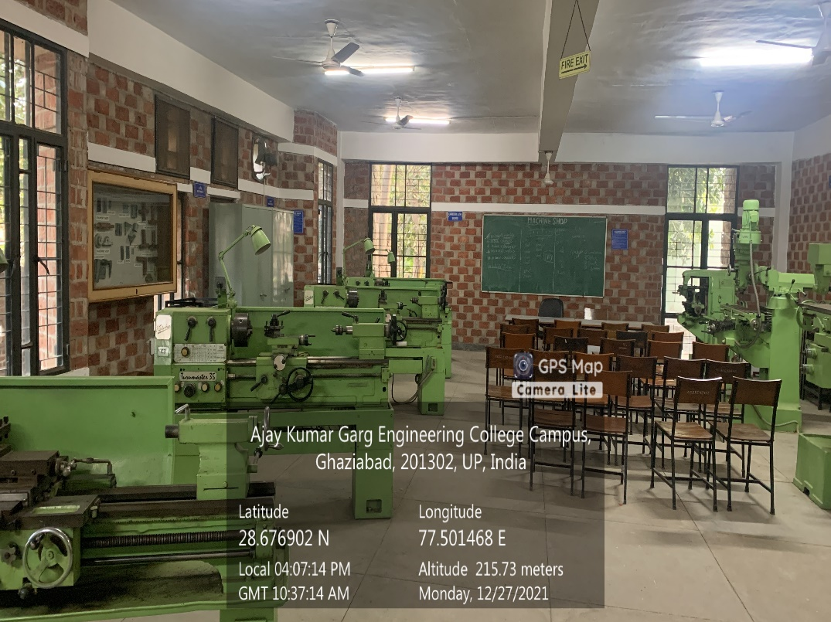

**MECHANICAL BLOCK GROUND FLOOR, MACHINE SHOP**

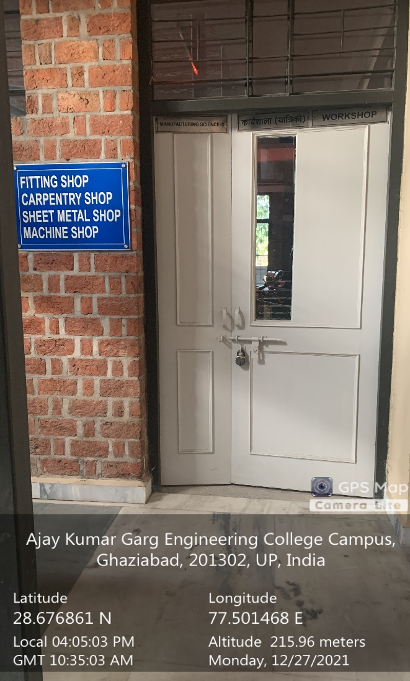

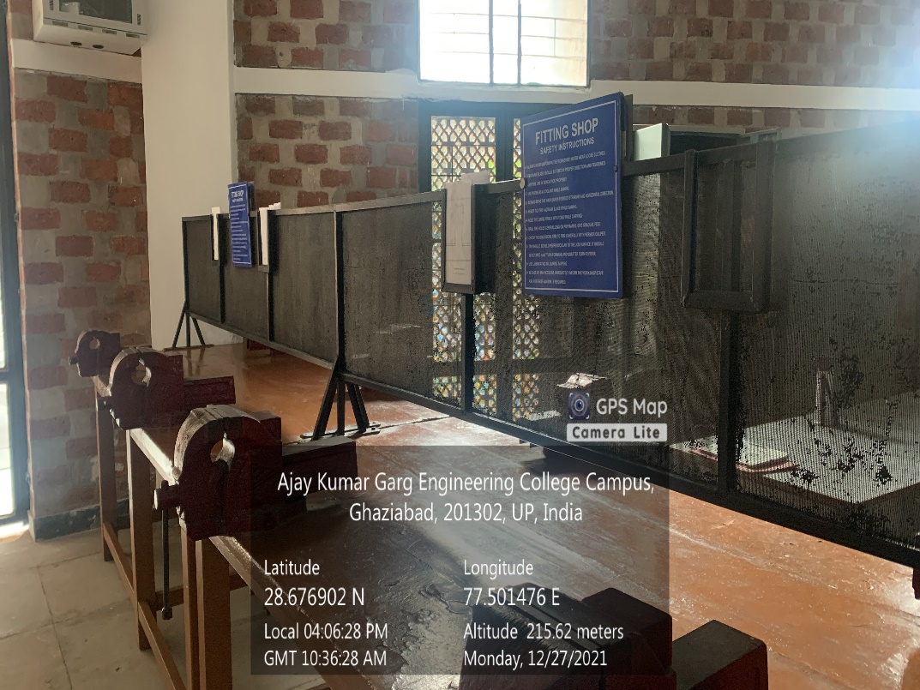

**MECHANICAL BLOCK GROUND FLOOR, FITTING SHOP**

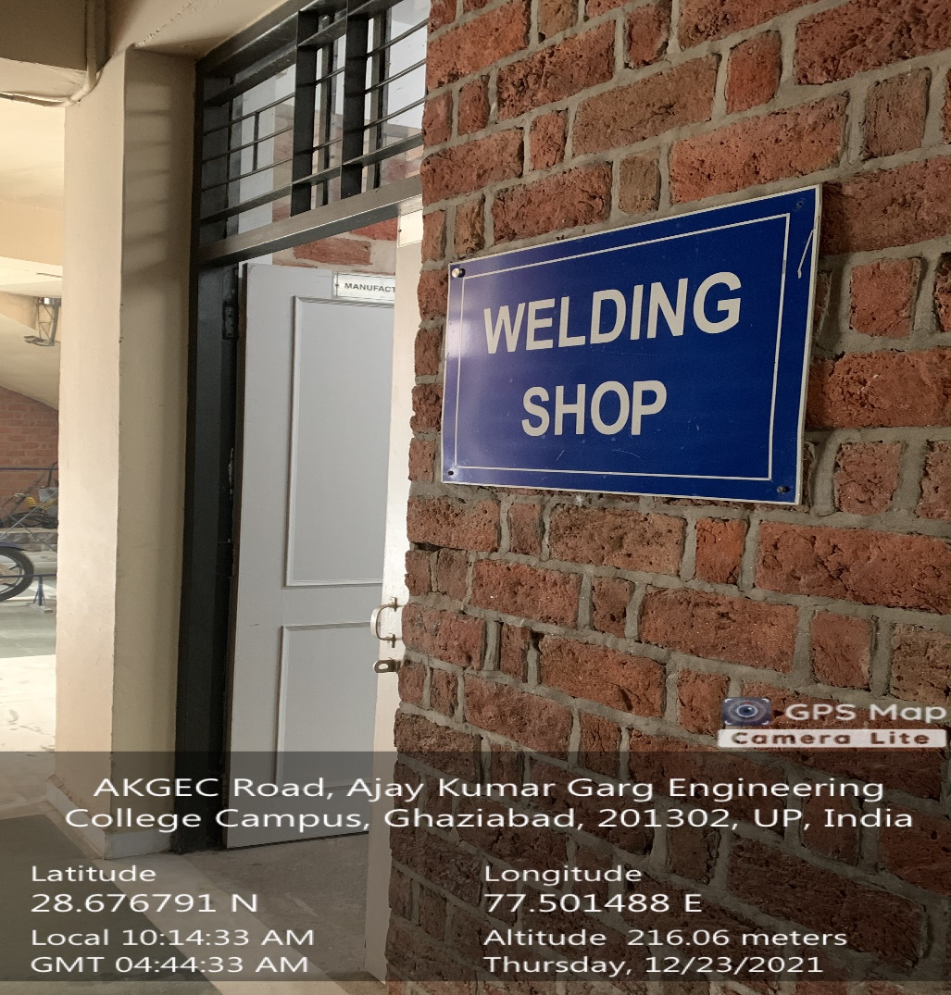

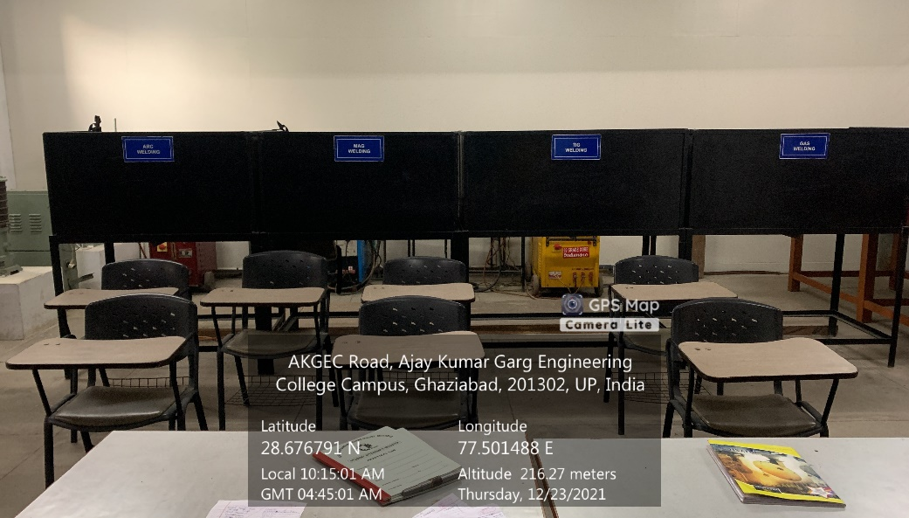

**MECHANICAL BLOCK GROUND FLOOR, WELDING SHOP**



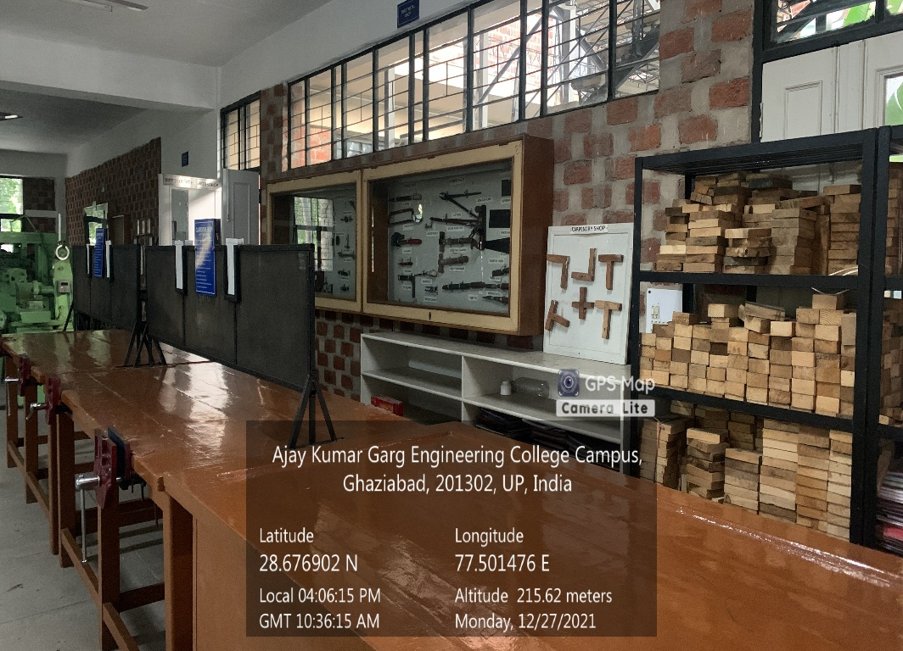

**MECHANICAL BLOCK GROUND FLOOR, CARPENTERY SHOP**

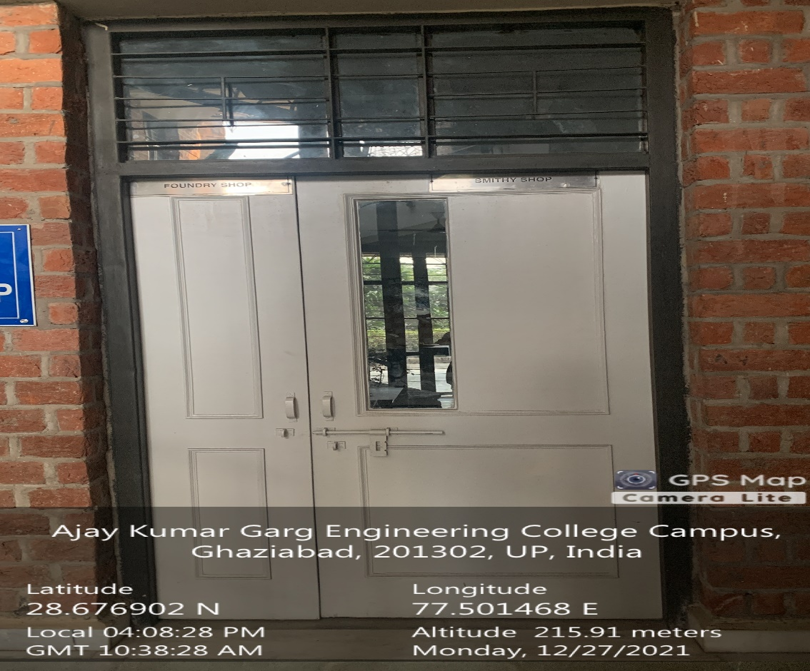

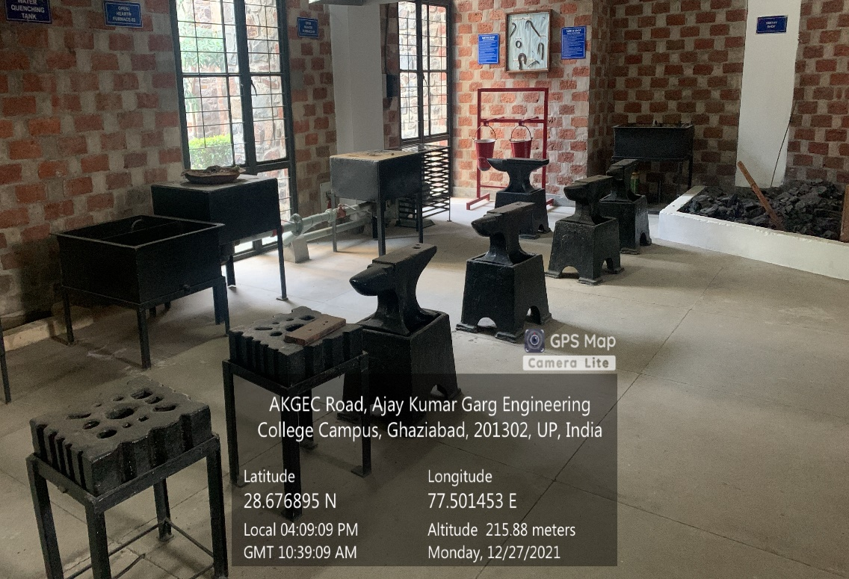

**MECHANICAL BLOCK GROUND FLOOR, SMITH SHOP**